

SMART AND INTERACTIVE ICT DEPARTMENT WEBSITE
Internet Programming 2 – Full Stack Web Application Project Report

Submitted To:
Mr. Xolisa Phillip Piyose
Department of Information and Communication Technology
Mangosuthu University of Technology

Group Information
Full Name | Student Number | Contribution
Mhle L | 22322987 | Login and AI Feature
Ngwadla M | 22310899 | Frontend Development and UXD
Msane ZN | 22415438 | Database Design
Shangase SS | 22315517 | Database integration using Express and Node.js
Mncwango AS | 22334567 | Testing and Documentation

Lecturer GitHub Account
xpiyose / xpiyose@gmail.com

Submission Date
13 May 2026

TABLE OF CONTENTS
- Executive Summary
- Introduction
- Problem Statement
- Project Objectives
- Analysis of Current ICT Department Website
- UXD Analysis and Frontend Redesign
- System Architecture
- Frontend Development and Interactivity
- Backend Development Using Node.js and Express
- Database Design and Integration
- CRUD Operations
- Middleware Implementation
- AI and Smart Website Functionality
- HTTP Requests and Responses
- Testing and Validation
- Security and Error Handling
- GitHub Repository and Version Control
- Challenges Experienced
- Recommendations and Future Improvements
- Conclusion
- References
- Appendices
PLEASE NOTE
Please note that our GitHub repository contains two branches: the main branch and the final branch. The main branch was the original branch created at the beginning of the project. However, as the project progressed, it became outdated due to several unnecessary and incomplete changes made during development.
For this reason, we created the final branch, which contains the updated, corrected, and complete version of the project intended for marking. We chose not to merge the branches in order to avoid conflicts and prevent the final working version from being affected by outdated changes.
Kindly use the final branch when reviewing and marking our project, as it reflects the latest collaborative work completed by the group.

1. EXECUTIVE SUMMARY
The purpose of this project was to redesign and improve the existing ICT Department website into a smart, interactive, responsive and database-driven full-stack web application. The system was developed using HTML, CSS, JavaScript, Node.js, Express.js and MySQL.
The project focused on solving common problems identified in traditional departmental websites such as poor navigation, limited interactivity, lack of personalization, weak responsiveness and absence of intelligent support features. The redesigned website provides a modern user experience that supports students, staff, prospective students and other stakeholders.
The developed system includes frontend and backend integration, responsive user interfaces, authentication functionality, programme information management, search functionality, dashboards, database connectivity, middleware implementation and intelligent website features. The backend communicates with the frontend through RESTful API routes while MySQL is used for data storage and retrieval.
The system demonstrates understanding of User Experience Design (UXD), client-side scripting, server-side programming, routing, middleware, CRUD operations, HTTP methods and smart web technologies.

2. INTRODUCTION
Modern websites are expected to provide more than static information. Users expect websites to be interactive, responsive, intelligent and easy to use. Educational institutions require systems that support communication, engagement, information retrieval and smart assistance.
The existing ICT Department website mainly provides static content and lacks advanced interaction, smart support and backend-driven functionality. This project was therefore developed to transform the website into a modern full-stack web application that aligns with current web development standards.
The project was developed using the following technologies:
- HTML5
- CSS3
- JavaScript
- Node.js
- Express.js
- MySQL Database
- REST APIs
- Middleware
- GitHub Version Control
The system demonstrates full integration between the frontend, backend and database.
3. PROBLEM STATEMENT
The traditional ICT Department website has several limitations that negatively affect user experience and system functionality. The website primarily displays static information and does not provide sufficient interaction between users and the system.
The following major problems were identified:
- Poor navigation structure
- Limited interactivity
- Lack of personalized user support
- No intelligent assistance functionality
- Weak mobile responsiveness
- Lack of backend integration
- No database-driven content
- Limited feedback mechanisms
- No login or dashboard functionality
- Poor scalability for future improvements
Because of these limitations, users may struggle to access important information efficiently. Prospective students may experience difficulties finding programme information while current students may lack centralized access to ICT departmental resources.
The project therefore aimed to redesign the website into a smart, interactive and data-driven departmental web application.

4. PROJECT OBJECTIVES
Main Objective
To redesign the ICT Department website into a smart, interactive and full-stack web application using frontend and backend technologies.
Specific Objectives
- To improve the user experience using UXD principles
- To develop responsive and modern web pages
- To implement meaningful JavaScript interactivity
- To build a backend using Node.js and Express.js
- To integrate a MySQL database into the system
- To implement CRUD operations
- To implement middleware for validation and error handling
- To integrate at least one intelligent website feature
- To demonstrate HTTP request and response handling
- To apply GitHub version control and collaborative development

5. ANALYSIS OF CURRENT ICT DEPARTMENT WEBSITE
A UXD evaluation was conducted on the current ICT Department website to identify usability problems and opportunities for improvement.

5.1 Identified Weaknesses
Problem | Description
Poor Navigation | Users struggle to find important information quickly
Static Content | Website lacks dynamic and interactive content
Weak Responsiveness | Some layouts are not optimized for mobile devices
Limited Search Functionality | Users cannot efficiently search for programmes or resources
Poor Visual Hierarchy | Important information is not emphasized effectively
Accessibility Issues | Limited accessibility support for users with disabilities
No Intelligent Features | Website does not provide automated assistance
Lack of Backend Integration | No live data processing or database communication
No User Authentication | Students and staff cannot access personalized dashboards
Minimal User Feedback | Forms and interactions do not provide sufficient feedback

5.2 UXD Principles Applied
The redesign was guided by UXD principles learned during the course, including:
- Simplicity
- Consistency
- Accessibility
- Usability
- Responsiveness
- Clear navigation
- User-centred design
The UXD lessons emphasized that good UX improves usability, accessibility and user satisfaction. The redesign therefore focused heavily on improving the user experience throughout the application.
6. UXD ANALYSIS AND FRONTEND REDESIGN
6.1 Overview of the Redesign
The website was redesigned with a modern and professional appearance suitable for a university ICT department. The interface uses clean layouts, structured content sections, responsive grids and modern typography.
The homepage includes:
- Hero section
- Programme information
- Industry partner section
- Staff and people sections
- Contact information
- Search functionality
- Login functionality
- Dashboard access

6.2 User-Centred Design
The system was designed around the needs of the following users:
- Prospective students
- Current students
- Parents
- Staff members
- Industry stakeholders
User needs identified included:
- Programme information
- Contact details
- Admission information
- Department news
- Student resources
- Academic guidance

6.3 Navigation Improvements
The redesigned navigation includes:
- Clear menu labels
- Responsive mobile navigation
- Search bar integration
- Consistent layout structure
- Quick access buttons
The navigation menu contains links such as:
- Home
- About
- Programmes
- People
- Campus
- Contact

6.4 Visual Design Improvements
The interface was redesigned using:
- Modern colour palettes
- Improved typography
- Consistent spacing
- Better alignment
- Improved contrast
- Professional cards and sections
- Responsive layouts

6.5 Accessibility Improvements
Accessibility features included:
- Readable font sizes
- Proper spacing
- Keyboard-friendly navigation
- Responsive layouts
- Alt text for images
- Better colour contrast

6.6 Responsiveness
The website was designed to function across:
- Desktop devices
- Tablets
- Mobile phones
CSS responsive design techniques such as flexible grids and adaptive layouts were implemented.

7. SYSTEM ARCHITECTURE
7.1 Overview
The project follows a three-tier architecture consisting of:
- Frontend Layer
- Backend Layer
- Database Layer

7.2 Frontend Layer
The frontend was developed using:
- HTML5
- CSS3
- JavaScript
Responsibilities of the frontend include:
- Displaying the user interface
- Handling user interaction
- Sending requests to the backend
- Displaying responses from the server

7.3 Backend Layer
The backend was developed using:
- Node.js
- Express.js
Responsibilities of the backend include:
- Handling routes
- Processing requests
- Validating data
- Communicating with the database
- Returning responses to the client

7.4 Database Layer
The database layer uses MySQL.
Responsibilities include:
- Storing user information
- Storing programme information
- Managing authentication data
- Retrieving data for the frontend

7.5 Architecture Flow
Browser (Frontend) ↔ Express Server (Backend) ↔ MySQL Database
This architecture ensures separation of concerns and improves scalability.

8. FRONTEND DEVELOPMENT AND INTERACTIVITY
8.1 HTML Structure
HTML was used to create the structure of the website, including:
- Navigation bar
- Hero section
- Programme cards
- Contact forms
- Dashboard pages
- Modal windows
8.2 CSS Styling
CSS was used to improve:
- Layout design
- Colours
- Typography
- Responsiveness
- Animations
- Spacing and alignment

8.3 JavaScript Interactivity
JavaScript was used extensively to create interactive functionality.
Interactive Features Implemented
Feature | Purpose
Search Functionality | Allows users to search programmes and content
Login Modal | Allows users to log into the system
Dynamic Navigation | Improves mobile usability
Programme Toggles | Displays entry requirements dynamically
Modal Windows | Improves user interaction
Dashboard Redirection | Redirects users based on roles
Client-side Validation | Prevents invalid form submissions
Responsive Menus | Enhances mobile navigation

8.4 Smart Search Functionality
The website includes a smart search input where users can search for programmes, projects and skills.
The frontend uses JavaScript fetch requests to communicate with backend API routes.

8.5 User Dashboards
Separate dashboard pages were created for:
- Students
- Staff members
This improves personalization and user experience.

9. BACKEND DEVELOPMENT USING NODE.JS AND EXPRESS
9.1 Overview
The backend server was developed using Express.js running on Node.js.
The backend handles:
- Routing
- Authentication
- API responses
- Database communication
- Request handling
- Response handling

9.2 Server Configuration
The server uses:
- express.json()
- CORS middleware
- express.static()
The application serves static frontend files from the src folder.

9.3 Implemented Routes
Login Route
app.post('/api/login', (req, res) => {
Purpose:
- Handles user authentication
- Validates user credentials
- Returns user information
Programmes Route
app.get('/api/programmes', (req, res) => {
Purpose:
- Retrieves programme information from the database
- Sends programme data to the frontend

9.4 HTTP Methods Used
Method | Purpose
GET | Retrieve information
POST | Submit data
PUT/PATCH | Update records
DELETE | Remove records
The system demonstrates understanding of RESTful communication.

9.5 Backend Advantages
The backend improved the system by:
- Supporting dynamic data
- Handling authentication
- Improving scalability
- Enabling database communication
- Supporting smart functionality

10. DATABASE DESIGN AND INTEGRATION
10.1 Database Technology
The project uses MySQL as the relational database management system.

10.2 Database Name: school_db

10.3 Database Tables
Users Table
Field | Data Type | Description
id | INT | Primary Key
name | VARCHAR | User Full Name
email | VARCHAR | User Email
password | VARCHAR | User Password
role | VARCHAR | User Role
Programmes Table
Field | Data Type | Description
id | INT | Primary Key
programme_name | VARCHAR | Programme Name
duration | VARCHAR | Programme Duration
description | TEXT | Programme Description

10.4 Database Connectivity
The backend connects to MySQL using the mysql2 package.
const mysql = require('mysql2');
The system establishes a connection using:
const db = mysql.createConnection({
host: 'localhost',
user: 'root',
password: '',
database: 'school_db'
});
10.5 Database Benefits
The database allows the system to:
- Store user information
- Retrieve programme data
- Support authentication
- Manage dynamic content
- Enable future scalability

11. CRUD OPERATIONS
The system demonstrates CRUD operations.
Operation | Description
Create | Add new records to the database
Read | Retrieve records from the database
Update | Modify existing records
Delete | Remove records

11.1 Create
Users and programme information can be inserted into the database.

11.2 Read
Programme data is retrieved using GET routes.

11.3 Update
Existing records can be modified using PUT or PATCH routes.

11.4 Delete
Records can be removed from the database using DELETE routes.
CRUD operations demonstrate meaningful interaction between the frontend, backend and database.

12. MIDDLEWARE IMPLEMENTATION
12.1 Overview
Middleware plays an important role in Express.js applications by processing requests before they reach routes.

12.2 Middleware Used
CORS Middleware
app.use(cors());
Purpose:
- Allows communication between frontend and backend
- Prevents cross-origin issues
JSON Middleware
app.use(express.json());
Purpose:
- Parses incoming JSON request bodies
- Allows API communication
Static Middleware
app.use(express.static('src'));
Purpose:
- Serves frontend files to users

12.3 Suggested Additional Middleware
Future improvements may include:
- Authentication middleware
- Route protection middleware
- Logging middleware
- Validation middleware
- Error-handling middleware
Middleware improves maintainability, security and scalability.

13. AI AND SMART WEBSITE FUNCTIONALITY
13.1 Overview
The project includes intelligent website functionality designed to improve user support and interaction.

13.2 Smart Features Implemented
Smart Search
The system includes a smart search feature that allows users to quickly locate programmes, skills and information.
The feature:
- Accepts user search input
- Processes the request dynamically
- Returns relevant programme suggestions
Personalized Dashboards
The login system supports user-based personalization.
Different dashboards can be shown for:
- Students
- Staff members
- Visitors

13.3 Benefits of the Smart Features
The smart functionality improves:
- User experience
- Navigation speed
- Information accessibility
- Personalization
- User engagement

13.4 Future AI Improvements
Possible future intelligent features include:
- AI chatbot assistant
- Recommendation engine
- Automated FAQ system
- Predictive search
- Real-time notifications

14. HTTP REQUESTS AND RESPONSES
14.1 Overview
The system demonstrates understanding of HTTP communication between the frontend and backend.

14.2 Request Flow
- User interacts with the frontend
- JavaScript sends a request to the server
- Express route processes the request
- Database query executes
- Response is returned to the frontend
- Frontend displays results to the user

14.3 Examples of Requests
Route | Method | Purpose
/api/login | POST | Authenticate users
/api/programmes | GET | Retrieve programme data

14.4 JSON Responses
The backend returns JSON responses such as:
{
"success": true,
"message": "Login successful"
}
This demonstrates proper client-server communication.

15. TESTING AND VALIDATION
15.1 Testing Conducted
The following testing activities were performed:
Test Type | Purpose
Functional Testing | Verify system features work correctly
Responsive Testing | Verify mobile responsiveness
Form Validation Testing | Ensure valid user input
Route Testing | Verify backend routes
Database Testing | Confirm database connectivity
Integration Testing | Ensure frontend and backend communication

15.2 User Evaluation
At least three users evaluated the system as required.
Evaluation Results
User Feedback | Improvement
Navigation easier to use | Improved menu structure
Interface more modern | Better layout and styling
Search functionality useful | Faster information retrieval
Mobile layout improved | Better responsiveness

15.3 Testing Outcome
The system successfully demonstrated:
- Backend integration
- Database communication
- Route functionality
- User interaction
- Dynamic content handling

16. SECURITY AND ERROR HANDLING
16.1 Security Measures
The following security considerations were implemented:
- Input validation
- Structured routing
- Backend request handling
- Controlled database access

16.2 Error Handling
The backend handles:
- Missing credentials
- Invalid logins
- Database errors
- Server errors
Example:
return res.status(400).json({
success: false,
message: 'Email and password are required'
});

16.3 Recommended Future Security Enhancements
Future improvements may include:
- Password hashing
- JWT authentication
- HTTPS deployment
- Session management
- Environment variable protection

17. GITHUB REPOSITORY AND VERSION CONTROL
17.1 GitHub Usage
GitHub was used for:
- Team collaboration
- Version control
- Code backup
- Project management

17.2 Repository Structure
The repository includes:
- Frontend files
- Backend files
- Database setup
- README documentation
- Package configuration

17.3 README File
The README contains:
- Project overview
- Installation instructions
- Dependency setup
- Database configuration
- Run instructions

17.4 Benefits of GitHub
GitHub improved:
- Collaboration
- Code tracking
- Team communication
- Project organization

18. CHALLENGES EXPERIENCED
Several challenges were experienced during development.
Challenge | Solution
Database connection issues | Verified MySQL configuration
Route debugging | Improved API testing
Responsive design problems | Used flexible layouts and media queries
Frontend-backend integration | Implemented fetch requests and JSON handling
Team coordination | Used GitHub collaboration
These challenges helped improve problem-solving and teamwork skills.

19. RECOMMENDATIONS AND FUTURE IMPROVEMENTS
The following improvements are recommended:
- Implement JWT authentication
- Add AI chatbot support
- Add admin management panel
- Add real-time notifications
- Integrate external APIs
- Add student enquiry management
- Improve analytics and reporting
- Deploy system online
- Add password encryption
- Add appointment booking system
These enhancements would further improve the usability and intelligence of the website.

20. CONCLUSION
The project successfully transformed the ICT Department website into a smart, interactive and database-driven full-stack web application.
The redesigned system demonstrates frontend development, backend integration, database connectivity, middleware implementation and intelligent website functionality. The project also demonstrated understanding of UXD principles, RESTful communication and full-stack web development concepts.

The website now provides:
- Improved user experience
- Responsive design
- Dynamic functionality
- Backend integration
- Smart interaction
- Database connectivity
- Better accessibility
- Personalized experiences
The project successfully met the assessment requirements and demonstrated practical application of Internet Programming 2 concepts.

21. REFERENCES
- MDN Web Docs. HTML, CSS and JavaScript Documentation.
- Express.js Official Documentation.
- Node.js Official Documentation.
- MySQL Official Documentation.
- UXD Internet Programming 2 Lesson Slides.
- GitHub Documentation.
- W3Schools Web Development Tutorials.

22. APPENDICES
Appendix A: Screenshots
Insert screenshots of:
- Homepage
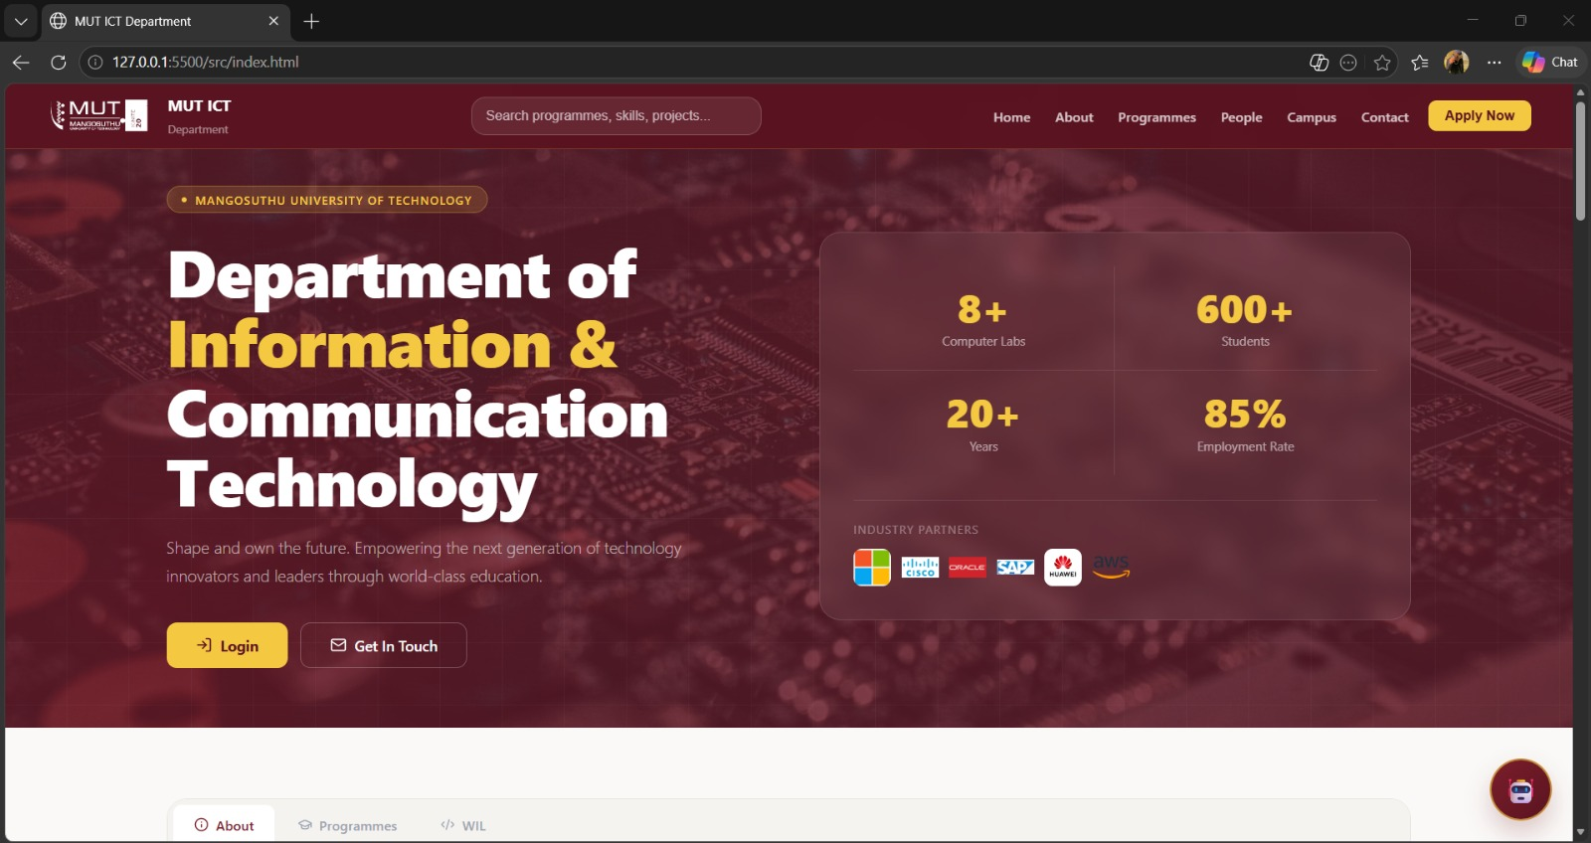
- Login Modal
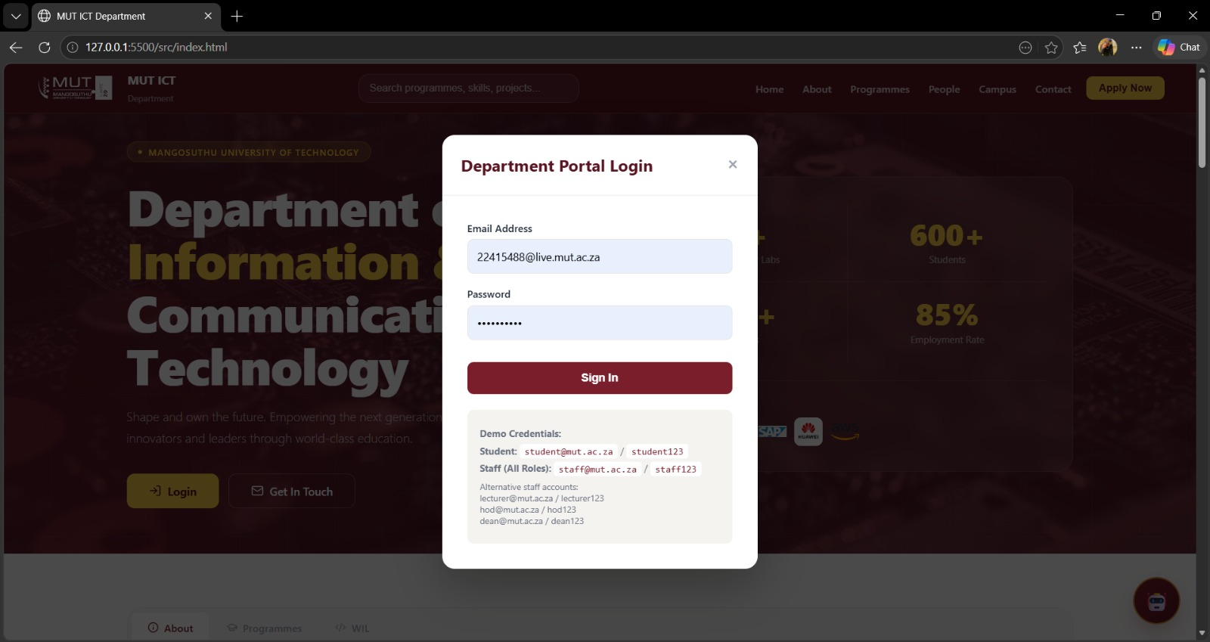

- Search Functionality
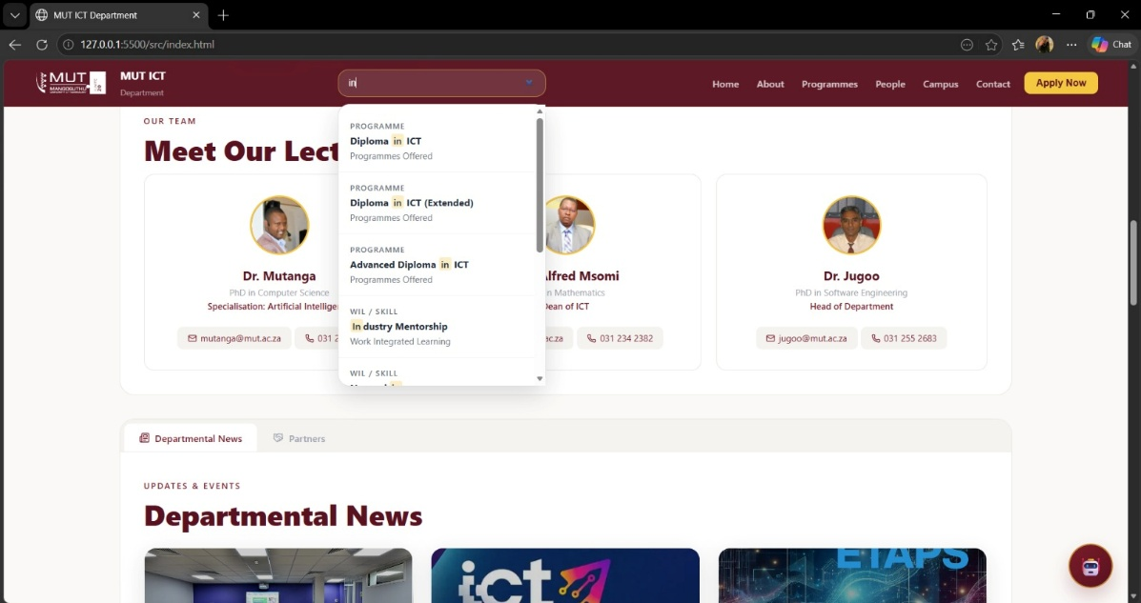
- Dashboards
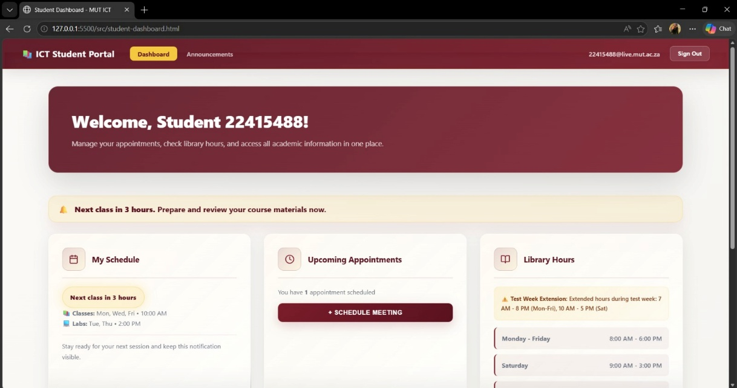
- Responsive Mobile View
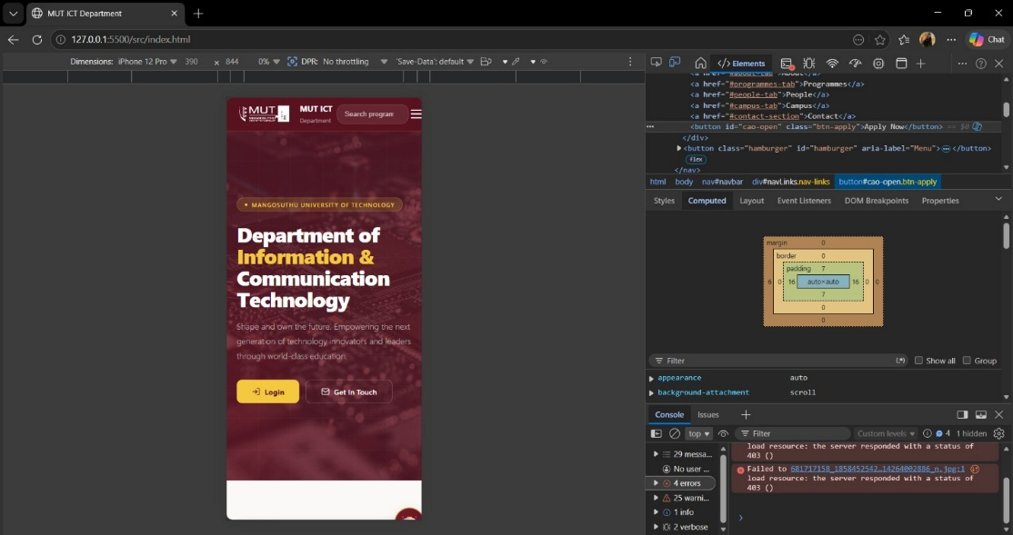
- Backend API Testing
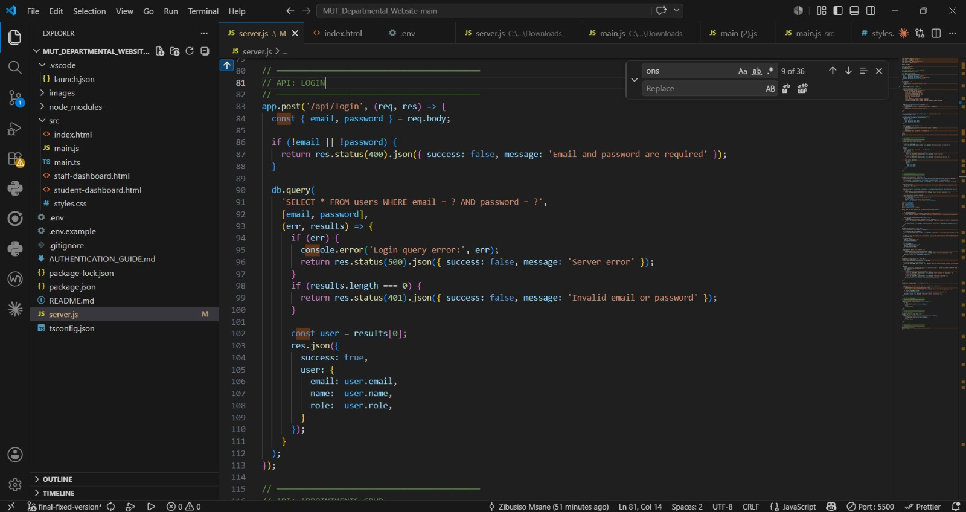
- Database Tables
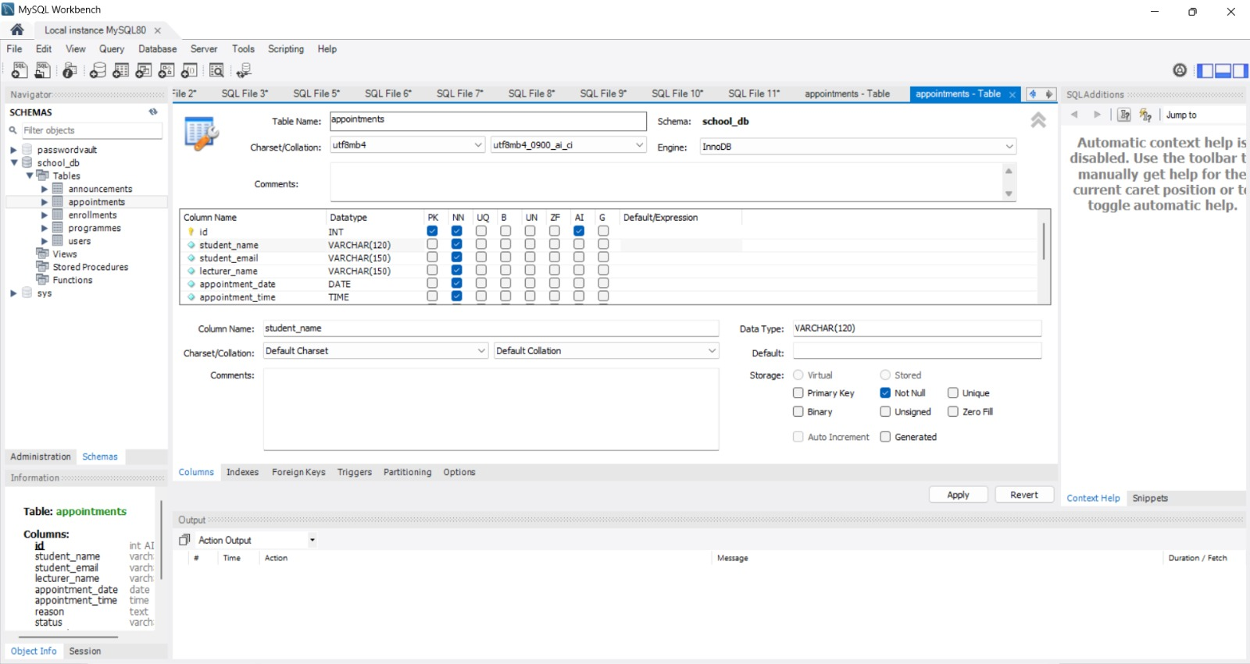

Appendix B: Installation Instructions
Step 1
Install dependencies:
npm install

Step 2
Configure MySQL database:
CREATE DATABASE school_db;
Step 3
Run the server:
node server.js
Step 4
Open the application:
http://localhost:3000
Appendix C: Sample Database Script
CREATE TABLE users (
id INT PRIMARY KEY AUTO_INCREMENT,
name VARCHAR(100),
email VARCHAR(100),
password VARCHAR(100),
role VARCHAR(50)
);

CREATE TABLE programmes (
id INT PRIMARY KEY AUTO_INCREMENT,
programme_name VARCHAR(255),
duration VARCHAR(100),
description TEXT
);
Appendix D: GitHub Repository Link
https://github.com/Mbali022019/MUT_Departmental_Website.git
Appendix E: Video Presentation Link

